Hi Sunny –

This next project will be another one based on designs and visuals.

I would like to produce similar scatter plots to the below examples:

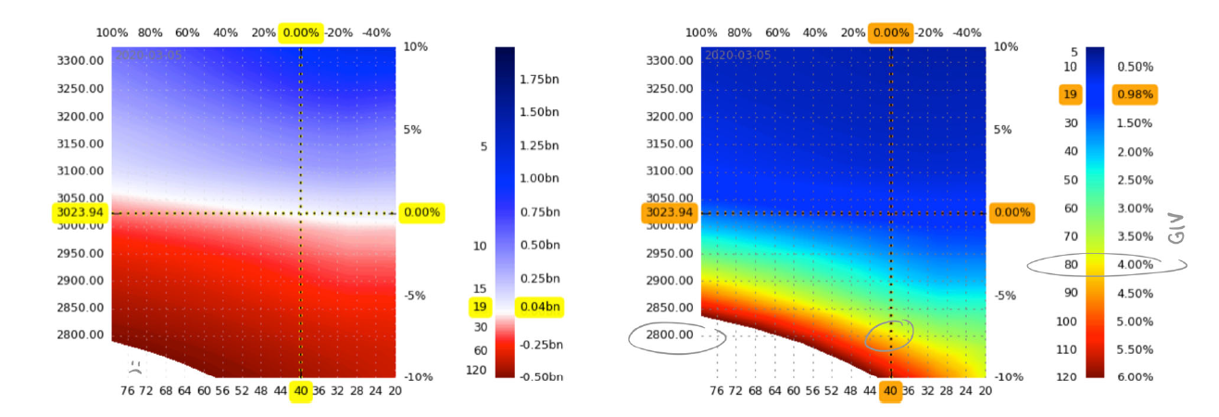

These scatter plots look like they were created from a dataframe comprised of three columns. The first two columns were used for the X and Y axis… while the third column was used to determine the magnitude of the color.

Can we try the same visuals / graphs using the four CSVs I sent over?

Each CSV contains columns “csi1” and “ga_csi1” which can be used for the X and Y axis of the scatter plot. Then, the values in “next_day_close” can be used for the magnitude of color. I think only two colors need to be used… green for positive values where a deeper / denser green represents the highest values on the scale… and red for negative values, where the most negative values will be the most red.